AJAX is the abbreviation formed from the first letter of Asynchronous JavaScript And XML, this enhances a set of development techniques that are used for building websites and web applications. AJAX’s core function is to upgrade the web content asynchronously, which means if a user’s accesses web browser that does not need to reload an entire web page when only a small portion of content on the page needs to change. For instance, asynchronous updating is Google’s - google suggest feature. Whenever we enter some search query in the search bar of Google that Google website automatically begins offering auto-complete options while typing, that’s AJAX in action. JavaScript is the J in AJAX, this is a scripting language used to automate website processes so web developers do not have to individually program each instance of the process that appears on a page. XML is the X in AJAX as it is used as a markup language, which means it is in the same family as language like HTML and CSS. This markup languages are coding language used to annotate parts of a web document that are intended to give web browser instructions about how to understand, process, and display a web page versus the actual text intended to be displayed on the page. While HTML and CSS focus on instructing how page content is displayed, whereas XML is used to transfer data stored on the page to the browsers that view it.

I think this AJAX application model is good for most of the software, because of Asynchronous helps to access the search box, JavaScript is help the search easy and faster, and XML show us the data that is in the page.

Accessing this application when connected to Internet Connection give most recent information that the data stored in the local to the application. However, AJAX does not allow the information storage to the local client, it will not work without the internet connection. This is the most important development for web application, and its importance is only growing in future.

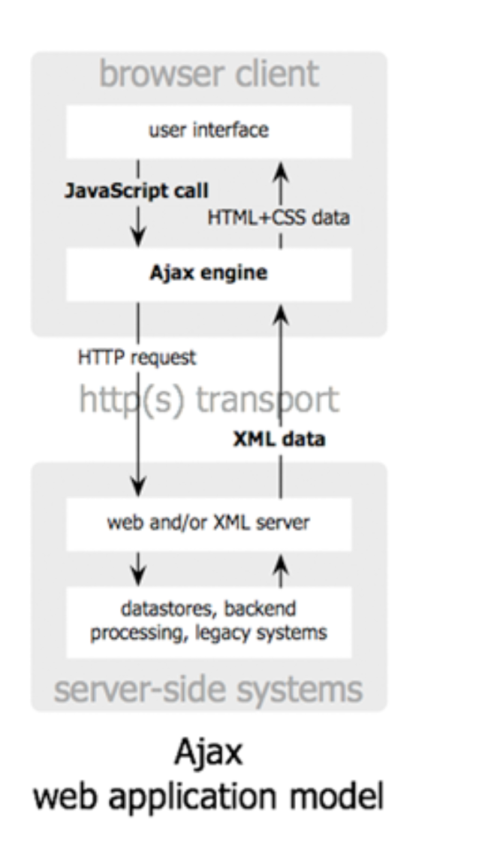

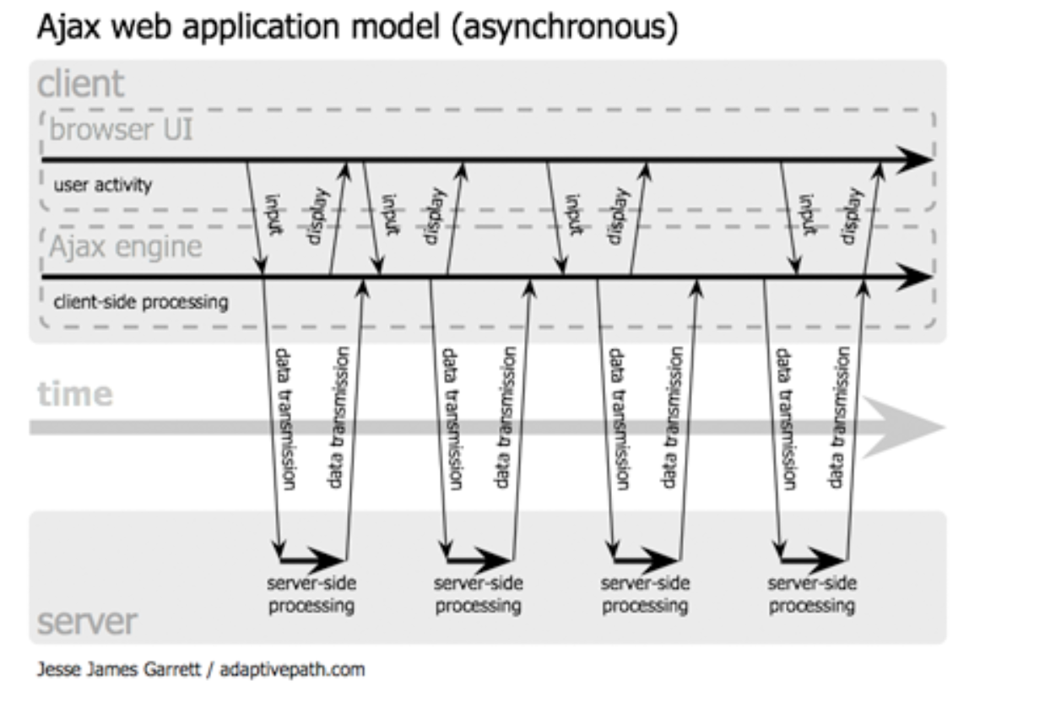

Reference:

1. <https://skillcrush.com/blog/what-is-ajax/>
2. <https://www.investopedia.com/terms/c/cloud-computing.asp>
3. <https://www.joe0.com/2016/12/19/ajax-model-good-or-bad/>

Data replication is a method of occupying a physical/virtual servers or cloud instance (primary instance) is continuously replicated or copied to a secondary servers or cloud instance (standby instance). This is also a form of clustering where all nodes in the cluster have the same/identical schema and data. To have high availability of the data. Even if a node goes down, the data is still available from other nodes in the cluster. Separate nodes for write and read. Data is replicated from the write cluster to all read clusters. This ensures that under high transaction volumes, the read operations are not getting delayed by write operations and vice-versa. There are multiple nodes for read and write operations. This ensures that the read and the write operations are load balanced across multiple nodes resulting in higher scalability and data throughput.

Clustering is when there is group of machines (nodes) hosting the same database schema on the same database software with some form of data exchange between these machines. From outside of the cluster, these machines are a single unite containing a union of the data that is spread across the nodes in the cluster. When your application accesses a cluster, the request is ultimately routed to a single node in the cluster for read or write operation.

References:

1. <https://us.sios.com/what-we-do/data-replication/>
2. <https://www.quora.com/What-is-the-difference-between-replication-partitioning-clustering-and-sharding#:~:text=Replication%20is%20a%20form%20of,data%20exchange%20between%20these%20machines.>